Title: Soft, Adhesive Matrix-Cell Bio-Composites from Orchid Stigma
Andres E. Ramos R.^{1,2#}, Yuliana Valdiviezo Cuenca³, Paula Yanez Contreras³, David Cuenca Fernández⁴, Frank Alexis³, Tetsuo Yamaguchi²
#Corresponding author
¹Orchidarc, Charity No. 1208062, S13 8DJ, Sheffield, UK
²Department of Biomaterial Sciences, Graduate School of Agricultural and Life Sciences, The University of Tokyo, Tokyo, Japan
³Department of Chemical Engineering, Universidad San Francisco de Quito (USFQ), Quito, Ecuador
⁴Department of Mechanical Engineering, Universidad San Francisco de Quito (USFQ), Quito, Ecuador
ORCID:
AERR 0009-0007-0422-8802
TY 0000-0003-1943-7790
YVC 0009-0005-9353-3344
PYC 0000-0002-6675-1072
DCF 0009-0008-7275-5820
FA 0000-0002-0597-7940
Abstract
Orchid stigmatic secretions are conventionally described as viscous fluids, but their rheological properties have not been quantified. We used oscillatory shear rheology, creep–recovery, polarised-light microscopy, gravimetry, and qualitative phytochemical screening to characterise stigmatic secretions from epidendroid hybrids representing five genera (Cattleya, Laelia, Dendrobium, Cymbidium, Phalaenopsis), with microscopy extended to nine. All specimens showed measurable linear viscoelastic ranges, with plateau storage moduli spanning more than two orders of magnitude (≈4 kPa in Dendrobium to 679 kPa in Cattleya), placing these materials along a viscoelastic solid-to-liquid spectrum rather than among simple fluids. Frequency sweeps revealed no detectable crossover in Cattleya, boundary behaviour in Phalaenopsis, and progressively higher-frequency crossovers in Laelia, Cymbidium, and Dendrobium; creep–recovery confirmed irrecoverable flow in three genera. At deposition-relevant frequencies most materials satisfied the Dahlquist criterion for compliant contact, whereas all stiffened substantially at departure-equivalent rates, generating a testable prediction of rate-dependent soft-adhesive function for a companion study. Microscopy revealed detached eleutherocytes within a continuous extracellular matrix in all nine genera, extending WDc-like organisation beyond Dendrobium. Water content and qualitative composition did not covary with stiffness, indicating that matrix structure underlies the observed mechanical diversity. We propose "stigmatic composite" as a more accurate working term than "stigmatic fluid."
Keywords: Orchid; stigmatic fluid; bio-composites; adhesion; rheology

Introduction
Successful fertilisation in orchids requires transfer of a pollinarium to the stigma and its retention within the stigmatic cavity long enough for pollen hydration, germination, and pollen-tube growth to proceed [1], [2]. Although pollinarium removal has been studied extensively from morphological and ecological perspectives [3], the stigmatic secretion that mediates the final step of deposition has rarely been treated as a material. In orchids this secretion is usually classified as the stigmatic fluid and a component of the wet stigma type [4]. Previous histochemical studies of the material have identified polysaccharides and arabinogalactan proteins [5], [6]. In several epidendroid taxa it also contains detached secretory cells suspended in a mucilaginous matrix, the WDc (wet detached-cellular) type [7]t, to our knowledge, its mechanical behaviour has not been quantified. As a result, recurrent descriptors such as “mucilage,” “viscous liquid,” or “glue” remain qualitative, and the material class of the secretion under pollination-relevant conditions remains unresolved [8], [9], [10].
This gap matters because successful deposition imposes mechanical demands that cannot be inferred from composition alone. During pollination in Epidendroideae, a pollinator-borne pollinarium is pressed into a secretion-filled stigmatic cavity under transient load, must remain embedded as the pollinator departs, and then remain in effective contact while hydration and germination proceed over hours to days [2], [8]. Whether the secretion accommodates insertion, resists displacement, and maintains contact thereafter depends on its viscoelastic response across timescales: the balance between elastic storage and viscous dissipation, and how that balance changes with deformation rate and strain amplitude, as in other soft adhesive systems [11], [12], [13], [14], [15]. These properties are measurable through storage modulus (G′), loss modulus (G″), tan δ, and their dependence on angular frequency (ω) and strain amplitude (γ₀), but such data have not previously been reported for orchid stigmatic secretions. Without them, functional interpretations of retention and hydration remain grounded mainly in anatomy and chemistry rather than material behaviour.
The broader wet-stigma literature does not resolve this issue. Across angiosperms, wet stigmas are defined by the presence of a surface exudate rather than a dry pellicle [4], and their chemistry has been studied extensively [16], [17], [18]. Mechanical classification, however, has not been established. That distinction matters, because a predominantly viscous fluid will accommodate a deposited body differently from a gel-like soft material capable of storing elastic stress and resisting displacement under load [13], [19], [20]. Standard rheology is impractical in most stigma systems because secretion volumes are extremely small, but epidendroid orchids are unusually tractable because their filled stigmatic cavities yield sufficient material from multiple flowers for bulk measurement.
A second motivation is that the secretion is often structurally non-homogeneous. Calder and Slater [5], [6] showed in Dendrobium speciosum that detached, viable secretory cells are suspended within a continuous mucilaginous matrix rich in acidic polysaccharides and arabinogalactan proteins and distinguished this WDc architecture from the classical wet papillate category of Heslop-Harrison [4]. Johansen [7] later termed these cells eleutherocytes and showed that they remain metabolically active and responsive to pollination status. Because these cells contribute to secretion through granulocrine release [6], the stigmatic material is better viewed as a cell–matrix system than as a simple extracellular exudate. Related WDc or WDc-like organisations have since been reported in other orchid taxa, including Rodriguezia, Cephalanthera and several Pleurothallidinae [8], [21], [22], [23], [24], suggesting that eleutherocyte-bearing secretions may be more widespread than previously appreciated. However, this literature remains largely anatomical and histochemical. It has not established how suspended cells relate to bulk mechanics, whether they influence yielding or frequency dependence, or how broadly this composite architecture extends across sampled epidendroid genera.
Here we address that gap using oscillatory shear rheology, creep-recovery testing, and polarised-light microscopy on stigmatic secretions from commercially cultivated hybrids representing five epidendroid genera, with microscopy extended to nine. We ask three questions. First, is the secretion better classified as a viscoelastic material than as a simple viscous fluid, and over what ranges of timescale and deformation? Second, is an eleutherocyte-containing cell-matrix architecture supported across sampled genera, and does variation in cellular loading coincide with measurable mechanical differences? Third, what do the measured material properties imply, conservatively and as testable predictions, for the mechanics of pollinarium capture and retention? By framing orchid stigmatic secretion as a soft matrix-cell material, we complement existing anatomical and chemical descriptions with quantitative criteria for its function during pollination.
Materials and Methods

Plant material
Fresh flowers of commercially cultivated hybrid orchids were obtained from nurseries and flower shops in the Tokyo metropolitan area, stored at 4 °C after cutting, and used within 4 days. Only flowers with yellow, undecayed pollinia, taken to indicate receptivity, were used. Genera, measurements performed, and specimen counts are summarised in Table 1. For rheology, biological material was pooled from 9–22 flowers of the same hybrid per run to obtain sufficient volume for the 10 mm parallel-plate geometry. The rheological unit analysed is therefore a pooled run from one sampled hybrid/specimen set, not an individual flower, and comparative statements are correspondingly restricted to the sampled material.
Table 1. Genera, measurements performed, and sample sizes.
Genus | Subtribe | Rheology specimens | Microscopy specimens | Water content (%) | Flowers per run
Cymbidium | Cymbidiinae | 2 | 3 | ✓ | 9–13
Dendrobium | Dendrobiinae | 1 | 3 | ✓ | 11–15
Cattleya | Laeliinae | 2 | 3 | ✓ | 6–7
Laelia | Laeliinae | 1 | 2 | ✓ | 8–12
Phalaenopsis | Aeridinae | 2 | 3 | ✓ | 15–19
Oncidium | Oncidiinae | — | 3 | ✓ | —
Masdevallia | Pleurothallidinae | — | 1 | — | —
Coelogyne | Coelogyninae | — | 1 | — | —
Vanda | Aeridinae | — | 1 | ✓ | —
Collection and handling
Stigmatic secretion was collected directly from the stigmatic cavity with a fine-tipped stainless-steel microspatula held above a water-filled container to reduce evaporative loss during handling. Pooled material was transferred immediately, without dilution, onto the lower rheometer plate inside the humidity enclosure described below.
Rheometry
All rheological measurements were performed on an Anton Paar MCR 302e rheometer in strain-controlled mode with a smooth stainless-steel parallel-plate geometry (diameter 10 mm). Temperature was controlled at 20.0 ± 0.1 °C using a Peltier lower plate. A custom 3D-printed resin humidity enclosure containing water-saturated sponge strips was used to reduce evaporation during extended runs (typically 2–5 h per loaded sample). Relative humidity inside the enclosure was not logged directly; residual dehydration was assessed operationally from repeated frequency sweeps on one loaded specimen (Phalaenopsis S2; Fig. S2), which bounds drift magnitude but does not establish genus-to-genus equivalence. In that control, performed on Phalaenopsis S2 approximately 2 h apart, G′ increased by 8.6–20.2% (mean 15%) and G″ by 6.0–12.0% (mean 9%), whereas tan δ remained nearly superimposed over the overlapping frequency range and shifted only slightly downward (mean Δtan δ = −0.028), indicating modest residual dehydration without qualitative reversal of viscoelastic class.
Samples were loaded centrally; the upper plate was lowered to a working gap of 0.50 mm (0.45 mm for Laelia) while maintaining normal force at 0.0 ± 0.1 N during loading, and excess material was trimmed with a spatula. Samples rested for 3 min before testing.
Amplitude sweeps were performed at ω = 10 rad s⁻¹ with γ₀ swept logarithmically from 0.01% to 10–100%, depending on genus. The linear viscoelastic range (LVR) was defined as the interval over which G′ remained within 5% of its low-strain plateau, calculated as the mean of the first three data points. The critical strain γc was taken as the upper boundary of this interval.
Frequency sweeps were performed at a fixed γ₀ within the LVR (0.05–1.0%, adjusted by genus; table 2) with ω swept logarithmically from 0.005 to 100 rad s⁻¹ at 4 points per decade; Dendrobium was extended to 300 rad s⁻¹.
Creep tests were stress-controlled at τ₀ = 7, 10 and 15 Pa, with 60 s creep followed by 260 s recovery at τ = 0 Pa. These were run sequentially on the same loaded specimen, with strain zeroed at each step. Compliance was calculated as J(t) = γ(t)/τ₀. The 7 Pa stress was within the LVR for all genera except Dendrobium; 10 and 15 Pa exceeded the linear limit for most genera and are therefore interpreted as nonlinear (apparent) creep. Recovery-phase strain was zeroed at stress removal by the instrument; raw recovery traces were shifted by +γ_{peak} to reconstruct the continuous deformation history before computing recovery metrics. Figure 4 plots recovery only, normalised by γ_{peak}, so all traces start at γ/γ_{peak} = 1 at the moment of stress release and decay toward zero with progressive recovery; the loading phase and full creep–recovery compliances are reported in figure S3. Recovery fraction was quantified as the percentage of γ_{peak} recovered after 264 s for genera with interpretable traces.
Cattleya was excluded from recovery analysis because peak strains at 10 Pa (~2 × 10⁻⁴) approached the angular displacement resolution of the 10 mm geometry. Laelia was excluded from quantitative recovery analysis because the shifted recovery trace fell ~23% of γ_{peak} below the pre-test baseline; this is attributed to a short acquisition delay between stress removal and the first recorded data point, during which rapid elastic recoil at timescales below the sampling interval occurred unrecorded. The instrument-reported γ_{peak} therefore underestimates the true peak strain. The Laelia trace is retained in figure 4 (clipped at γ/γ_{peak} = 0) as a qualitative indicator of near-complete elastic recovery.
Where multiple amplitude sweeps were available from the same specimen (Laelia, Dendrobium), sweeps showing mutual consistency (<5% difference in G′ plateau) were averaged. Sweeps performed after large-strain cycling that showed >10% softening were excluded as indicating irreversible structural damage. Where more than one rheological specimen was tested (Cattleya, Cymbidium, and Phalaenopsis), the primary specimen is reported in the main tables and inter-sample variability is shown in figure S1.
The full sequential protocol on a loaded sample was amplitude sweep, frequency sweep, creep–recovery, thermal cycling, and final frequency sweeps. Thermal-cycling results are not interpreted in the main text and the protocol is described only in the Supplementary Methods. Final frequency sweeps at 20 °C served as an internal drift check for cumulative dehydration effects. Because explicit gap-dependence or roughened-plate slip diagnostics were not performed in the present study, absolute moduli are interpreted cautiously and comparisons are made primarily among specimens tested under identical geometry and loading conditions.
When comparing oscillatory rheology to single-event pollinator deformations, rate-equivalent angular frequencies are taken as ω = 2π/t for sustained contacts (where t is the contact duration) and ω ≈ γ̇ for transient deformations (where γ̇ ≈ v/L is the characteristic shear rate). Both conventions are used in figures 2–3 and in the Discussion as appropriate to the regime considered.
Optical microscopy
Fresh stigmatic secretion was mounted hydrated between slide and coverslip and imaged unfixed and unstained using an Olympus BX53 microscope in polarised-light transmission mode at 5×, 10× and 50× magnification. Absolute cell dimensions were calibrated against a stage micrometer, and scale bars are shown on all micrographs. Cell aspect ratio was measured from individual cell outlines in ImageJ v1.54 (NIH). Projected two-dimensional cell area fraction (φ₂D) was quantified from 50× polarised-light micrographs using the Image Analysis Toolbox in MATLAB R2025b (MathWorks). Here φ₂D denotes the segmented cell-occupied area divided by total field area in projection. Fields in which segmentation failed because of opacity, severe overlap, or out-of-focus structure were excluded. φ₂D is used as a proxy for cellular loading only and does not account for depth-of-field effects or cell overlap; it should therefore not be interpreted as a direct volumetric fraction.
Water-content estimation
Stigmatic secretion from Cymbidium, Dendrobium, Cattleya, Phalaenopsis, Vanda and Oncidium was weighed in the hydrated state on a microbalance (UXILAII RS232), air-dried for 48 h at ambient conditions (~20 °C; ~40% RH), and reweighed. Water content was calculated as
$$watercontent=\frac{wetmass-drymass}{wetmass}×100\%.$$
Phytochemical analyses
Qualitative phytochemical assays were performed on pooled stigmatic secretion from Cattleya, Phalaenopsis, Cymbidium, Dendrobium, and Oncidium to screen for broad compositional classes: carbohydrates (Molisch), aromatic-amino-acid-containing proteins (xanthoproteic), glycosides (Keller–Kiliani), and terpenoids (Salkowski). Positive and negative controls were run with each assay. Because all assays are qualitative, inter-genus differences are interpreted as presence/absence rather than quantitative rankings.
Scanning electron microscopy of freeze-dried secretion and thermogravimetric analysis were performed as complementary compositional checks on the same five genera; instrument conditions and sample preparation are described in the Supplementary Methods, and the corresponding data are reported in figures S9 and S10.
Results
Linear viscoelastic range and strain sensitivity
Figure 1 shows well-defined low-strain plateaux in all five genera, with plateau storage moduli spanning more than two orders of magnitude: Cattleya ≫ Laelia > Phalaenopsis ≈ Cymbidium ≫ Dendrobium (table 2). Four genera maintained G′ > G″ throughout the LVR; Dendrobium was the only sampled material in which G″ > G′ across the full strain range, and low-strain tan δ followed the same ordering. The LVR limit (γc, 5% criterion) varied inversely with stiffness, consistent with strain-sensitive weak-gel-like behaviour in the stiffer materials [25], [26], [27], [28]. Inter-sample variability is shown in figure S1.
Frequency dependence and crossover behaviour
Figure 2 shows that within the LVR, both G′ and G″ increased with angular frequency in all genera, indicating structured viscoelastic behaviour rather than an ideal frequency-independent gel. The crossover ordering under identical geometry and loading conditions was: no detected crossover in Cattleya; very low-frequency crossover in Laelia (ω_{c} ≈ 0.008 rad s⁻¹; near the measurement bound); sample-dependent near-crossover in Phalaenopsis (table 2, footnote §); intermediate crossover in Cymbidium (ω_{c} ≈ 4.2 rad s⁻¹); and highest-frequency crossover in Dendrobium (ω_{c} ≈ 19 rad s⁻¹). Relaxation timescales τ ≈ 1/ω_{c} are listed in table 2. Figure 3 reframes this ordering as a continuous tan δ gradient: Cattleya remained below unity across the entire measured range, Dendrobium exceeded it over nearly the full range, and the three remaining genera transitioned through tan δ = 1 at progressively lower frequencies, showing the spectrum from persistently solid-like to predominantly liquid-like behaviour within a single secretion type.
Residual dehydration under the humidity enclosure was assessed by repeating the frequency sweep on a loaded Phalaenopsis specimen approximately 2 h later (figure S2). Modest stiffening occurred (mean ΔG′ ≈ 15%), but tan δ remained nearly superimposed and shifted away from unity, confirming that the observed crossover was not generated by water loss.
Creep–recovery under sustained loading
Figure 4 shows recovery traces for four genera, normalised by γ_{peak}. Among the three for which quantitative recovery was possible, none recovered fully: Cymbidium recovered 61% of peak strain, Phalaenopsis 23%, and Dendrobium 16%, leaving substantial irrecoverable deformation in all cases. In the framework of Malkin et al. [28], this is the defining behaviour of a yielding liquid, a material that stores elastic stress on short timescales but dissipates irreversibly under sustained loading. The recovery fraction constitutes a second axis of differentiation: Cymbidium retains the most elastic character under sustained load, Dendrobium the least, broadly tracking the crossover frequency ordering. The applied stress of 10 Pa exceeded the oscillatory LVR for all three genera, so the values in table 2 should be read as apparent compliances under nonlinear conditions rather than linear material constants (linearity tests in figure S3). γ_{peak} (the strain reached at end of 60 s creep loading; table 2) reproduces the oscillatory stiffness ordering.
Laelia is shown qualitatively only; its shifted recovery trace dropped ~23% of γ_{peak} below the pre-creep baseline (a timing artifact; see Methods) and is clipped at γ/γ_{peak} = 0 in figure 4. The rapid decay nonetheless suggests near-complete elastic recovery on the 264 s timescale, consistent with its low-frequency crossover (ω_{c} ≈ 0.008 rad s⁻¹; τ ≈ 118 s) and identifying it as the most solid-like of the four genera plotted. Cattleya may behave similarly under larger applied stresses, but at 10 Pa its strain drifted at the instrument resolution floor and was not interpretable.
Table 2. Rheological parameters for five epidendroid genera.
Genus | G′plateau (kPa) | γ_{c}(5%) | ω_{c} (rad s⁻¹) | τ (s) | γ_{peak} | Recovery (%)
Cattleya | 679 | 0.11 | — | — | 2.2 × 10⁻⁴ * | — *
Laelia | 32.950 | 0.39 | 0.008 † | 118 | 1.5 × 10⁻³ | — ‡
Phalaenopsis | 23.4 | 1.52 | ~0.2 § | ~5 | 7.5 × 10⁻³ | 23
Cymbidium | 21.4 | 0.64 | 4.2 | 0.24 | 4.9 × 10⁻³ | 61
Dendrobium | 3.845 | 4.77 | 18.8 | 0.05 | 9.0 × 10⁻² | 16
* At angular displacement resolution floor; recovery not interpretable. † Near low-frequency measurement bound; treat as order-of-magnitude estimate. ‡ Shifted recovery trace falls ~23% of γ_{peak} below the pre-test baseline (residual strain −3.5 × 10⁻⁴ fractional), attributed to a short delay between stress removal and the first recovery data point, during which rapid elastic recoil occurred unrecorded. The instrument-reported γ_{peak} therefore underestimates the true peak strain. Creep-phase compliance J(60 s) = 1.53 × 10⁻⁴ Pa⁻¹ is stress-independent across 5–10 Pa (CV = 0.3%; Fig. S3) and remains reliable.
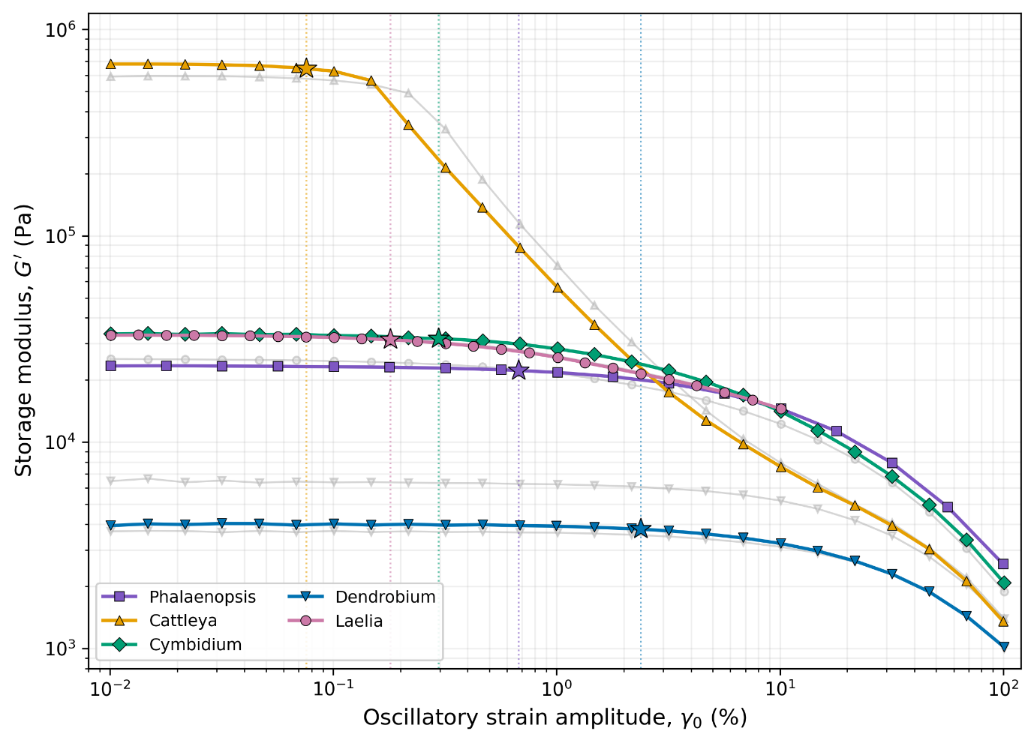
Figure 1. Amplitude sweeps of stigmatic secretions from five epidendroid genera at ω = 10 rad s⁻¹, T = 20 °C (conditions in Methods; γc values in Table 2). (a) Storage modulus G′ vs. strain amplitude γ₀. Filled symbols: primary sweep per genus; grey symbols: alternate sweeps/additional samples. Stars mark the LVR limit γc (5% criterion). (b) Loss factor tan δ = G″/G′; dashed line marks tan δ = 1. Three genera remain solid-like (tan δ < 1) at low strain; Cattleya transitions above unity shortly beyond the LVR; Dendrobium is loss-dominated throughout. Artefact note: at γ₀ ≈ 0.01%, measured torques approach instrument resolution for the lowest-modulus genera; these points are approximate.
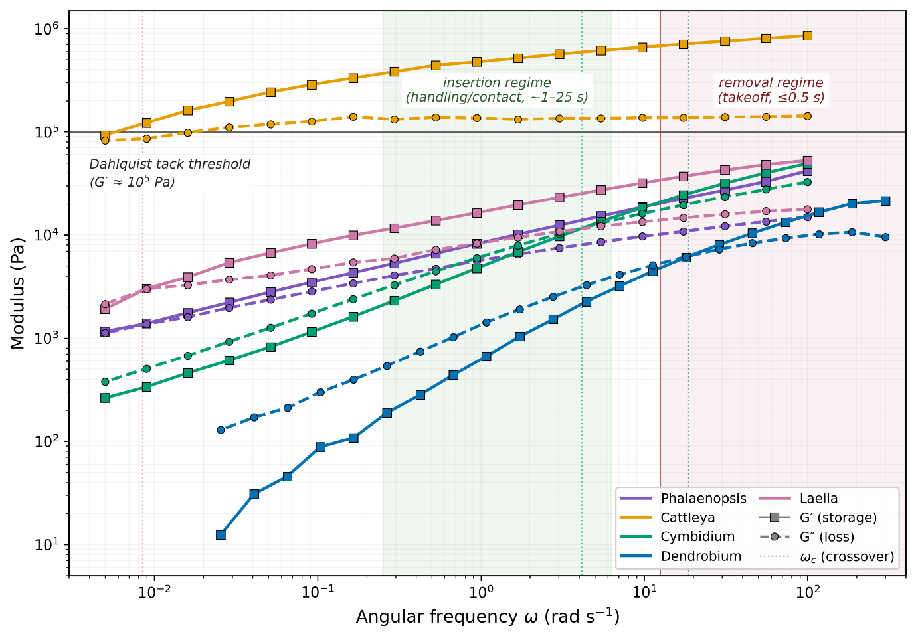
Figure 2. Frequency sweeps showing G′ (filled symbols, solid lines) and G″ (open symbols, dashed lines) vs. angular frequency ω for five genera (strain amplitudes within LVR; table 2). Vertical dotted lines: G′–G″ crossover frequency ω_{c} Cattleya shows no crossover over the measured range; Phalaenopsis is sample-dependent (near-crossover in S1), crossover at ω_{c} ≈ 0.2 rad s⁻¹ in S2); Laelia/Cymbidium/Dendrobium cross at progressively higher frequencies. Horizontal grey line: Dahlquist tack threshold (G′ ≈ 10⁵ Pa)[29]. Vertical bands indicate deposition-equivalent (ω ≈ 2π/t for t ≈ 1–25 s, green) and withdrawal-equivalent (ω ≳ 10² rad s⁻¹, red) angular frequencies; see Discussion.
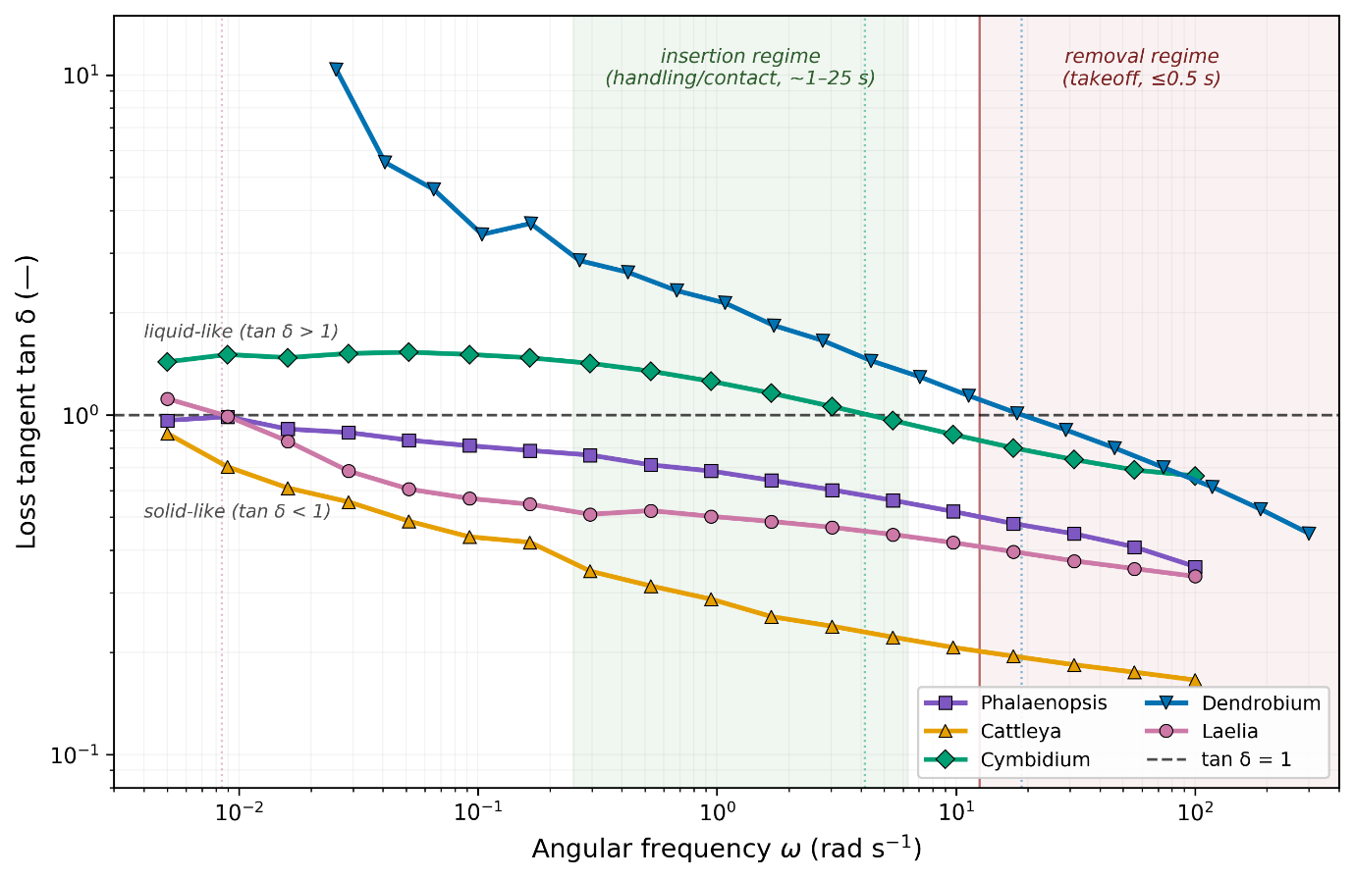
Figure 3. Loss tangent tan δ = G″/G′ vs. angular frequency ω, derived from figure 2. Dashed line: tan δ = 1 Cattleya remains below unity throughout; Phalaenopsis is sample-dependent (S1 near-crossover, S2 crosses at ω_{c} ≈ 0.2 rad s⁻¹; see Table 3). Laelia crosses unity near its lowest measured frequency; Cymbidium crosses near ω_{c} ≈ 4.2 rad s⁻¹. Dendrobium exceeds unity over nearly the entire range. Tan δ ranges are given in table 3. Bands and conventions as in figure 2.
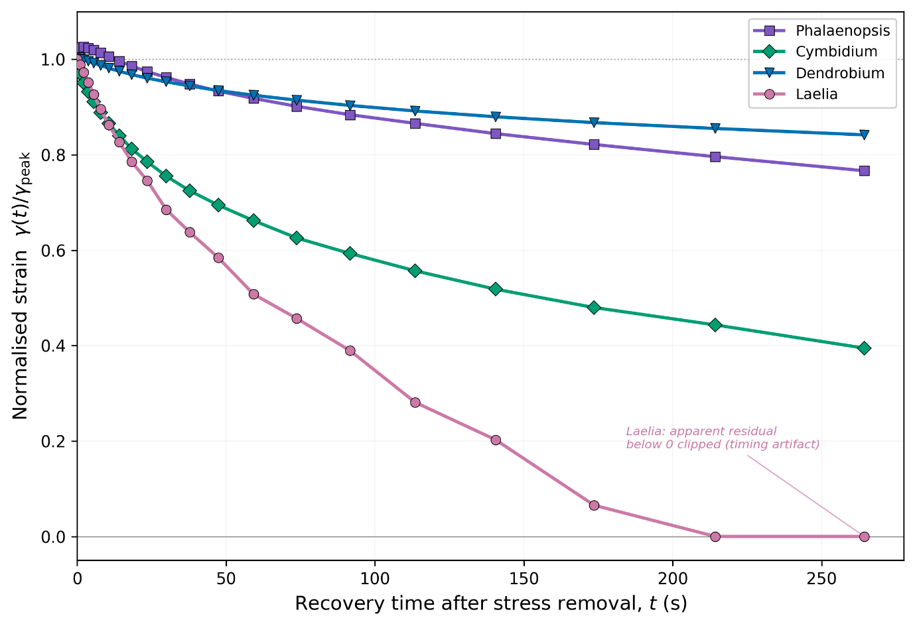
Figure 4. Recovery phase of creep–recovery tests for four epidendroid genera, normalised by peak strain γ_{peak} at end of 60 s creep loading; t = 0 is the moment of stress release. Dendrobium retains 84% of γ_{peak} (16% recovery), Phalaenopsis 77% (23%), Cymbidium 39% (61%). The Laelia trace is clipped at γ/γ_{peak} = 0; the underlying shifted trace falls ~23% of γ_{peak} below the pre-creep baseline due to an acquisition timing artifact (see Methods) and is shown qualitatively only. Loading-phase compliance and stress-linearity tests for all five genera are in figure S3.
Microscopy
Cell–matrix composite architecture across genera
Figures 5 and 6 show a consistent biphasic organisation in all nine sampled genera: discrete detached cells, termed eleutherocytes following Johansen [7] suspended within a continuous extracellular matrix. This architecture was observed in Cymbidium, Dendrobium, Oncidium, Cattleya, Laelia, Coelogyne, Phalaenopsis, Vanda and Masdevallia, extending WDc-like organisation beyond its original description in Dendrobium [5]–[8]. To our knowledge, seven of these genera (Cattleya, Laelia, Coelogyne, Phalaenopsis, Vanda, Oncidium, Masdevallia) are reported here for the first time.
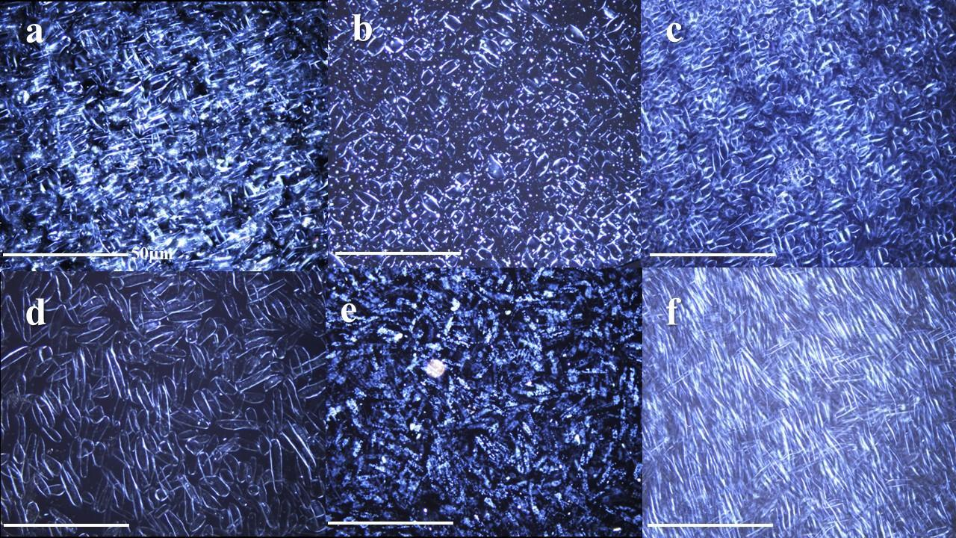
Figure 5 Low-magnification (10×) transmission micrographs. Panels (a) Cymbidium, (b) Dendrobium, (c) Oncidium, (d) Cattleya, (e) Coelogyne, (f) Phalaenopsis. showing field-scale organisation of detached cells within a continuous matrix. Scale bar: 50 µm.
Eleutherocyte morphotypes
Figure 6 shows that eleutherocytes varied along two principal axes: cell shape, quantified by aspect ratio (AR; table 5), and intracellular optical content. Along the shape axis, cells ranged from spheroid (AR median < 2; Oncidium) through fusiform (AR ~2–4; Dendrobium, Laelia, Vanda, Cymbidium, Cattleya) to filamentous (AR > 4; Coelogyne, Phalaenopsis). Along the content axis, cells were either optically loaded, containing visible vacuolar structures or refractile granules (Cymbidium, Dendrobium, Coelogyne) or optically clear, with little discernible intracellular content (Oncidium, Cattleya, Laelia, Phalaenopsis). Vanda exhibited mixed characteristics, with both vacuolate and empty cells, and showed the broadest shape heterogeneity. Masdevallia appeared filamentous but material was insufficient for quantification. All genera showed within-sample shape diversity; category boundaries are continuous rather than discrete.
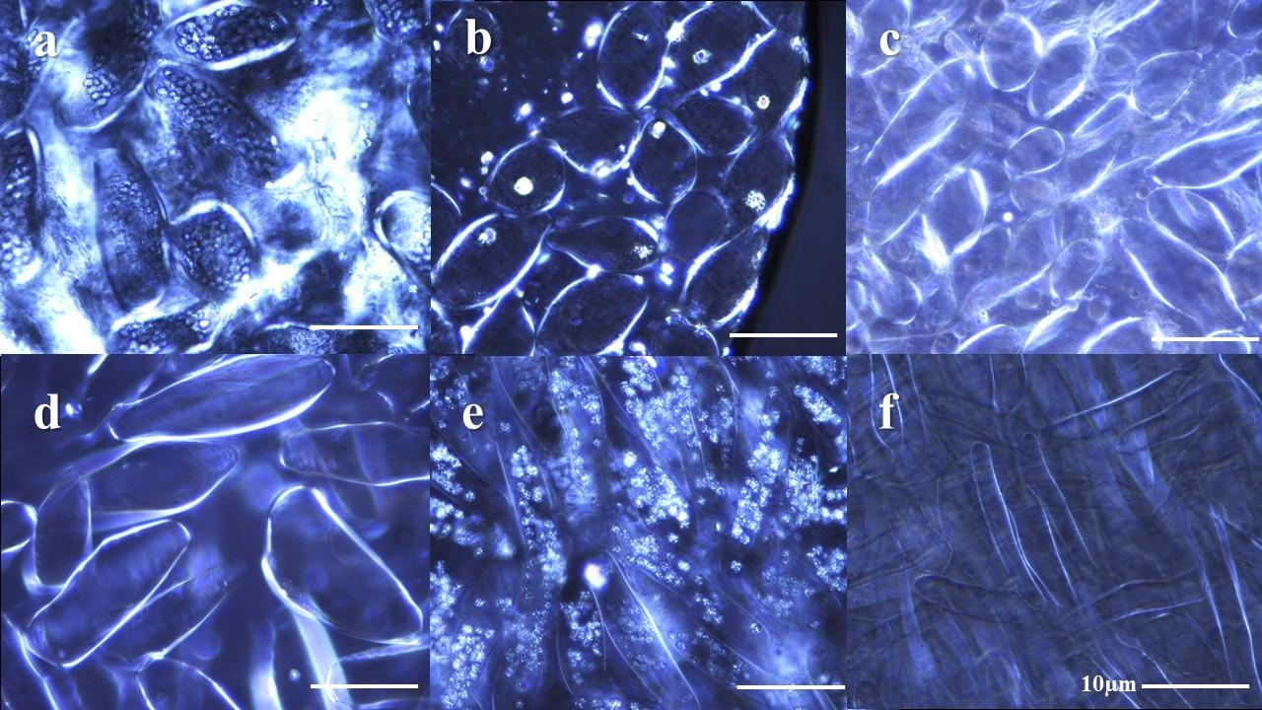
Figure 6 High-magnification (50×) transmission micrographs of fresh, unstained stigmatic secretion.(a) Cymbidium (cells with abundant refractile granules), (b) Dendrobium, (c) Oncidium, (d) Cattleya, (e) Coelogyne (elongated cells densely packed with refractile granules), (f) Phalaenopsis (high-aspect-ratio elongated cells); scale bar: 10 µm.
Projected cell area fraction
Figure 7 shows that projected two-dimensional cell area fraction (φ₂D) varied substantially among genera, from lowest in Vanda through Oncidium, Dendrobium, Cymbidium, Cattleya, Laelia, and Coelogyne, to highest in Phalaenopsis. The Phalaenopsis value is an upper-bound estimate because overlapping cells in transmission inflate apparent occupied area, and confidence in Cattleya and Laelia estimates is limited by small field counts (n = 3 and n = 2 respectively). φ₂D is a projection-based proxy for cellular loading, not a direct volumetric fraction.
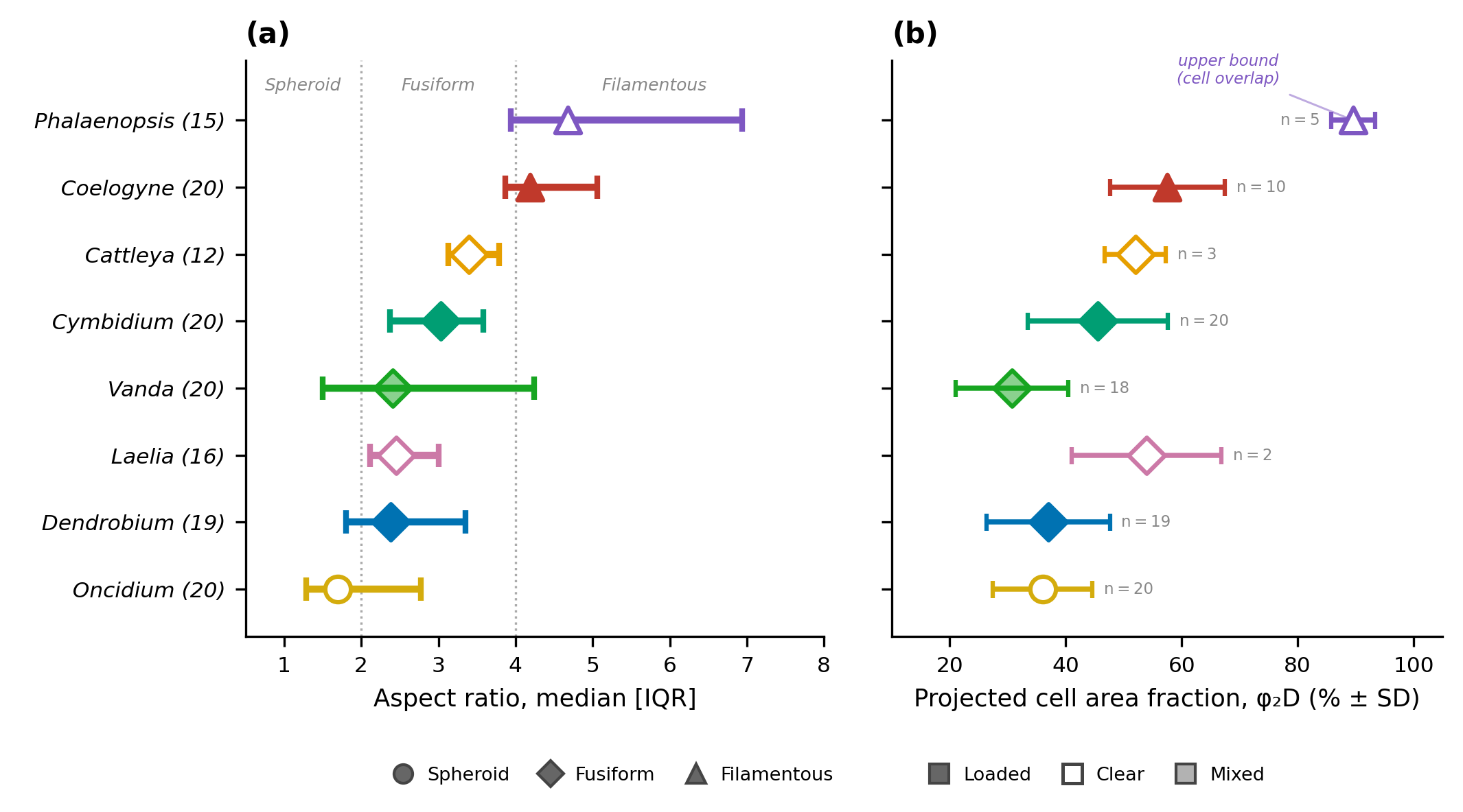
Figure 7. Eleutherocyte morphometry across eight epidendroid genera (50× polarised-light microscopy). (a) Morphology (b) Projected cell area fraction.
Water content and composition
Figure 8(a) shows that gravimetric water contents ranged from 62.8% (Cymbidium) to 91.5% (Phalaenopsis) and did not covary with stiffness. Cattleya, the stiffest sampled secretion, had intermediate water content (70.3%); Dendrobium, the softest, was the most hydrated among the rheology genera (77.8%); and Phalaenopsis, the most hydrated overall, retained only intermediate stiffness. Hydration alone therefore does not explain the observed modulus hierarchy.
Qualitative phytochemical screening of five genera (Figure 8b) revealed a shared compositional core. Carbohydrates were detected in all five genera (Molisch), consistent with the polysaccharide-rich matrix characterised biochemically in Dendrobium speciosum [5], [6]. All five genera also gave positive xanthoproteic responses, indicating proteins with aromatic residues. Terpenoid detection (Salkowski) was universal, weaker in Cattleya and stronger in Phalaenopsis and Oncidium. Keller–Kiliani was positive in Cattleya, Dendrobium, and Oncidium but weak or inconclusive in Cymbidium and Phalaenopsis. Representative positive-assay images per genus, together with SEM of freeze-dried secretion and thermogravimetric traces, are provided as complementary compositional support in figures S4–S10. Because all assays are qualitative, inter-genus differences are interpreted as presence/absence indicators rather than quantitative rankings.

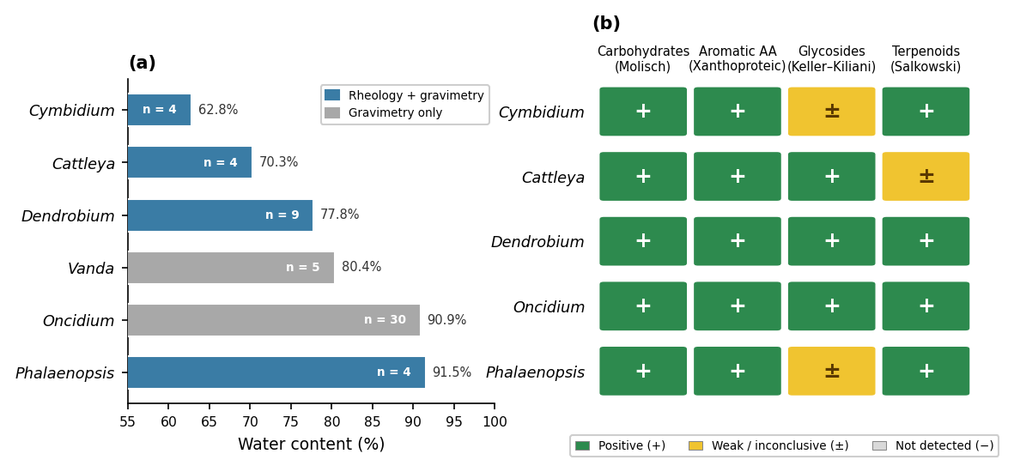
Figure 8: a) Gravimetric water content (%). Blue bars: genera with both rheology and gravimetry data; grey bars: gravimetry only. Sample sizes (n = flowers) are shown within each bar. (b) Qualitative phytochemical screening of five genera. Green (+): positive; yellow (±): weak or inconclusive; grey (−)
Discussion
Sampled epidendroid stigmatic secretions span a viscoelastic solid–to–liquid spectrum
The principal result is that the sampled stigmatic secretions are structured viscoelastic materials, not simple viscous fluids. Across the five genera measured rheologically, all specimens displayed a measurable linear viscoelastic range, frequency-dependent moduli, and in four of five genera, regimes in which elastic storage exceeded viscous dissipation. These features place the sampled materials along a viscoelastic solid-to-liquid spectrum. At one extreme, the sampled Cattleya maintained G′ > G″ across the full accessible frequency and strain range with no detectable crossover, consistent with a viscoelastic solid under the tested conditions. At the other, Dendrobium crossed at the highest frequency (ω_{c} ≈ 19 rad s⁻¹), confining solid-like behaviour to short timescales and behaving as a viscoelastic liquid over most of the measured window. Cymbidium (ω_{c} ≈ 4.2 rad s⁻¹) and Laelia (ω_{c} ≈ 0.008 rad s⁻¹) were intermediate by crossover ordering, though Laelia's relaxation time of approximately 2 min or roughly twice the creep duration, places it closest to elastic-dominated behaviour on the 60 s timescale of the creep test, consistent with the near-complete recovery suggested by its creep trace (figure 4). Phalaenopsis occupied a specimen-dependent boundary. These classifications may correspond to weak-gel and yielding-liquid categories as defined by Malkin et al. [28] and Picout and Ross-Murphy [28], but confirming those assignments would require gelation kinetics, Winter–Chambon analysis, or direct yield-stress measurements that were not performed here. The present evidence is sufficient, however, to reject the default assumption that orchid stigmatic exudate is a mechanically unstructured fluid.
Rate-dependent material response and pollination timescales
The frequency dependence documented in figures 2–3 acquires direct functional significance when interpreted through the framework of rate-dependent adhesion. In pressure-sensitive adhesive science, the Dahlquist criterion identifies G′ < 10⁵ Pa as a necessary condition for a material to make conformal contact under light pressure; materials exceeding this threshold are too stiff to wet a surface and form an adhesive bond [15]. Reported pollinator visit durations on individual orchid flowers are typically 15–25 s in Orchidoideae [30], of which the pressing contact during pollinarium deposition occupies a fraction; the corresponding frequency for a deposition event on the order of seconds is ω ≈ 1 rad s⁻¹. At this frequency, four of the five sampled materials (Laelia, Phalaenopsis, Cymbidium, and Dendrobium) satisfy the Dahlquist criterion, with G′ values ranging from approximately 1 to 30 kPa (figure 2). The sampled Cattleya material does not: its G′ exceeds 10⁵ Pa across essentially the full measured range, and its narrow LVR is more consistent with a material that resists deformation than one that accommodates insertion. At higher speeds, corresponding with departure-equivalent frequencies at or above ω = 100 rad s⁻¹, near the upper bound of the present measurements, all genera stiffen substantially, with Cymbidium and Phalaenopsis reaching approximately 40–65 kPa and Cattleya approaching 10⁶ Pa (figure 2; figure S1). The sampled materials are therefore not frequency-independent ideal gels; they stiffen progressively with loading rate.
This rate dependence becomes functionally suggestive when matched against pollinator kinematics. Honeybee flight speeds are of order 1–3 m s⁻¹ [31]; a conservative departure speed of 0.5 m s⁻¹ acting over an estimated Cymbidium stigmatic cavity depth of approximately 5 mm yields a nominal withdrawal timescale of ~10 ms, corresponding to an effective deformation rate on the order of 10² s⁻¹. At such rates, all sampled materials would be firmly within their elastic-dominated regime (G′ ≫ G″), maximising resistance to removal. By contrast, during slow deposition the lower-modulus genera of Dendrobium through Phalaenopsis would be more compliant and, for those with crossovers, approaching their viscous-dominated regime. The system thus exhibits a built-in asymmetry: compliant during slow insertion, resistant during fast withdrawal. This is a defining characteristic of rate-dependent soft adhesives [15], [32], [33].
This analogy rests on three simplifications. First, the dimensional estimate treats the stigmatic cavity as a uniform-gap shear geometry, which it is not; real deformation fields are three-dimensional and inhomogeneous. Second, the Dahlquist criterion was developed for synthetic polymer films rather than hydrated biological composites, and the 10⁵ Pa threshold is a guideline rather than a sharp boundary [15]. Third, pollinator departure speeds are variable and poorly constrained for most orchid systems [34,35]. With those caveats, the frequency-sweep data establish that the sampled stigmatic composites possess rate-dependent stiffening of the kind and magnitude required for soft adhesive function across a biologically plausible range of timescales. Whether any of these materials are demonstrably optimised for adhesive retention remains a direct, testable prediction for a companion study that measures pollinarium withdrawal forces across controlled loading rates (Ramos et al., in preparation).
The matrix governs bulk stiffness
Neither cell morphology, projected cellular loading, nor hydration state correlates simply with mechanical ordering. Phalaenopsis, with the highest projected φ_{2D} and filamentous clear cells, has comparable plateau stiffness to Cymbidium, which has moderate φ_{2D} and loaded fusiform cells (G′_{plateau} ≈ 23 vs 21 kPa). Cattleya, by far the stiffest sampled material (679 kPa), has moderate φ_{2D} and clear cells, whereas Dendrobium, the softest (3.8 kPa), has lower φ_{2D} but loaded fusiform cells. Similarly, gravimetric water content does not track stiffness: Phalaenopsis is the most hydrated of the rheology genera (91.5%) yet moderately stiff, Cymbidium the least hydrated (62.8%) yet only marginally stiffer, and Cattleya, by far the stiffest, has intermediate water content (70.3%). These dissociations indicate that bulk stiffness is governed primarily by the extracellular matrix, its polymer chemistry, cross-link topology, and hydration structure. Rather than by cellular reinforcement as classically understood in filled-gel mechanics [20], [34], [35].
The qualitative phytochemical profile of carbohydrates and aromatic-amino-acid-bearing proteins in all five genera tested, with variable terpenoid and glycoside responses, is consistent with a polysaccharide–protein composite matrix of the kind characterised quantitatively in D. speciosum [5], [6]. Scanning electron microscopy of freeze-dried secretion (figure S9) shows a continuous film-forming matrix in all five genera, and thermogravimetric traces (figure S10) share a principal degradation event at 230–270 °C while differing in non-volatile residue, together consistent with a shared polysaccharide-dominated backbone carrying genus-level compositional variation. The qualitative nature of the phytochemical assays, and the drying-induced collapse inherent to SEM and TGA sample preparation, preclude quantitative correlation with rheological properties. A detailed comparative FTIR-ATR compositional survey of stigmatic gels and viscidia across 22 genera is presented elsewhere (Ramos et al., in preparation).
These findings support interpreting eleutherocyte function as primarily biological rather than mechanical. Johansen [7] showed that Dendrobium eleutherocytes are metabolically active, respond differentially to compatible versus self-pollination, mobilise stored contents accordingly, and lie at the first interface encountered by germinating pollen tubes. The granule-loaded cells observed in Cymbidium, Dendrobium, and Coelogyne are consistent with living secretory elements involved in nutritional provisioning, recognition signalling, or both. The optically clear cells in Cattleya, Laelia, Oncidium, and Phalaenopsis may represent a different secretory state, a depleted or quiescent phase, or a genuinely distinct cell type; the present optical data cannot discriminate among these possibilities. More broadly, the extension of WDc-like organisation to all nine sampled genera, seven of which have not, to our knowledge, previously been reported to contain detached stigmatic cells, supports treatment of these secretions as cell–matrix systems rather than homogeneous exudates, but does not by itself establish universality across Epidendroideae.
For these reasons, “stigmatic composite” is a more accurate working term than “stigmatic fluid.” It captures both the biphasic architecture documented microscopically and the rheological evidence that the material stores elastic stress over biologically relevant timescales. The word composite acknowledges the presence of a cellular phase without implying that it mechanically reinforces the matrix in the classical sense. By contrast, “stigmatic fluid,” “mucilage,” or “viscous secretion” obscure the material’s measured elastic storage, its finite-timescale structure, and the metabolically active cells it contains.
Limitations
These interpretations remain provisional for several reasons. The humidity enclosure reduced residual dehydration but did not eliminate it, as shown by the modest modulus drift in figure S2. Wall slip and edge fracture were not explicitly tested. Low-torque and inertia limits may constrain the weakest and highest-frequency measurements, respectively. Sequential testing on the same loaded sample may have introduced deformation-history effects. Pooling secretion from multiple flowers obscured inter-flower variability, and independent rheological replication per genus remained limited. Microscopy has analogous constraints: φ₂D is a projected proxy, Phalaenopsis values are inflated by cell overlap, and some genera are represented by few valid fields. Phytochemical assays are qualitative and do not support quantitative compositional ranking; SEM micrographs of freeze-dried material (figure S9) and thermogravimetric traces (figure S10) are reported as complementary compositional support, but their sample preparation unavoidably collapses hydrated microstructure and they therefore cannot resolve the native gel architecture. Finally, interpreting oscillatory data through the Dahlquist criterion is a dimensional analogy, not a validated constitutive model for these materials; the rate-dependent adhesion framework proposed here generates testable predictions but has not itself been tested directly within the present study.
Conclusion
Across sampled epidendroid orchid hybrids and species, the stigmatic secretion behaved as a viscoelastic material spanning solid-like to liquid-like behaviour. Microscopy revealed detached eleutherocytes embedded in a continuous extracellular matrix in all sampled genera, supporting a cell–matrix biocomposite interpretation and extending WDc-like organisation beyond Dendrobium. Qualitative phytochemistry, SEM, and TGA together indicated a shared carbohydrate-dominated compositional core with genus-level variation. We propose the term stigmatic composite in place of stigmatic fluid and recommend further investigation of eleutherocyte diversity and their role following pollination.

References
[1] L. A. Nilsson, “Orchid pollination biology,” Trends in Ecology & Evolution , vol. 7, no. 8, p. 255, Aug. 1992, doi: 10.1016/0169-5347(92)90170-g.
[2] S. D. Johnson and T. J. Edwards, “The structure and function of orchid pollinaria,” Plant Systematics and Evolution , vol. 222, p. 243, Jan. 2000, doi: 10.1007/bf00984105.
[3] M. Thielen, D. Voigt, F. Gallenmüller, T. Speck, and S. N. Gorb, “‘Push and Pull’: Biomechanics of the Pollination Apparatus of Oncidium spp.,” Frontiers in Mechanical Engineering , vol. 6, Jan. 2021, doi: 10.3389/fmech.2020.635694.
[4] J. S. Heslop‐Harrison, “The Angiosperm Stigma,” 1992, p. 59. doi: 10.1007/978-3-642-77677-9_6.
[5] A. Slater and D. M. Calder, “Fine structure of the wet, detached cell stigma of the orchid Dendrobium speciosum Sm.,” Sexual Plant Reproduction , vol. 3, no. 1, Feb. 1990, doi: 10.1007/bf00189953.
[6] D. M. Calder and A. Slater, “The Stigma of Dendrobium speciosum Sm. (Orchidaceae): A New Stigma Type Comprising Detached Cells Within a Mucilaginous Matrix,” Annals of Botany , vol. 55, no. 3, p. 297, Mar. 1985, doi: 10.1093/oxfordjournals.aob.a086906.
[7] B. Johansen, “Incompatibility in Dendrobium (Orchidaceae),” Botanical Journal of the Linnean Society , vol. 103, no. 2, p. 165, Jun. 1990, doi: 10.1111/j.1095-8339.1990.tb00183.x.
[8] G. Gerlach, “Post-pollination phenomena in orchids – or the long journey of pollen from pollination to fertilization,” Nov. 2022.
[9] D. Schlee and F. Ebel, “NOTE ON THE CHEMICAL NATURE OF THE ADHESIVE OF VISCID DISCS IN CATASETUM FIMBRIATUM LINDL. (ORCHIDACEAE),” American Journal of Botany , vol. 70, no. 6, p. 872, Jul. 1983, doi: 10.1002/j.1537-2197.1983.tb06425.x.
[10] H. Kobayashi and J. Arditti, “Rostellum in orchids,” Lankesteriana , Dec. 2024, doi: 10.15517/lank.v24i3.63156.
[11] E. Insuasti‐Cruz et al. , “Natural Biomaterials from Biodiversity for Healthcare Applications,” Advanced Healthcare Materials , vol. 11, no. 1, Oct. 2021, doi: 10.1002/adhm.202101389.
[12] T. Lutz, C. Kımna, A. Casini, and O. Lieleg, “Bio-based and bio-inspired adhesives from animals and plants for biomedical applications,” Materials Today Bio , vol. 13, p. 100203, Jan. 2022, doi: 10.1016/j.mtbio.2022.100203.
[13] Y. Huang, Y. Wang, L. Sun, R. Agrawal, and M. Zhang, “Sundew adhesive: a naturally occurring hydrogel,” Journal of The Royal Society Interface , vol. 12, no. 107, p. 20150226, May 2015, doi: 10.1098/rsif.2015.0226.
[14] M. Anne, B. Nicholas, and M. L. Lindsey, “Polymer Gel Rheology and Adhesion,” in InTech eBooks , 2012. doi: 10.5772/36975.
[15] C. Creton, “Pressure-Sensitive Adhesives: An Introductory Course,” MRS Bulletin , vol. 28, no. 6, p. 434, Jun. 2003, doi: 10.1557/mrs2003.124.
[16] J. D. Rejón et al. , “Proteomics profiling reveals novel proteins and functions of the plant stigma exudate,” Journal of Experimental Botany , vol. 64, no. 18, p. 5695, Oct. 2013, doi: 10.1093/jxb/ert345.
[17] J. Y. Y. Lau, C. Pang, L. Ramsden, and R. M. Saunders, “Stigmatic exudate in the Annonaceae: Pollinator reward, pollen germination medium or extragynoecial compitum?,” Journal of Integrative Plant Biology , vol. 59, no. 12, p. 881, Sep. 2017, doi: 10.1111/jipb.12598.
[18] J. D. Rejón et al. , “The plant stigma exudate,” Plant Signaling & Behavior , vol. 9, no. 4, Mar. 2014, doi: 10.4161/psb.28274.
[19] J. F. Douglas, “Weak and Strong Gels and the Emergence of the Amorphous Solid State,” Gels , vol. 4, no. 1, p. 19, Feb. 2018, doi: 10.3390/gels4010019.
[20] T. van Vliet, “Rheological properties of filled gels. Influence of filler matrix interaction,” Colloid & Polymer Science , vol. 266, no. 6, p. 518, Jun. 1988, doi: 10.1007/bf01420762.
[21] J. Prutsch and R. Schill, “The stigma of Cephalanthera (Orchidaceae) provides a link between primitive and derived Epidendroideae,” Nordic Journal of Botany , vol. 20, no. 5, p. 599, Dec. 2000, doi: 10.1111/j.1756-1051.2000.tb01611.x.
[22] C. A. E. Leitão and Â. L. Cortelazzo, “Structure and histochemistry of the stigmatic and transmitting tissues of Rodriguezia venusta (Orchidaceae) during flower development,” Australian Journal of Botany , vol. 58, no. 3, p. 233, May 2010, doi: 10.1071/bt09178.
[23] A. B. R. de Almeida, E. de C. Smidt, and É. Amano, “Evolution of anatomical characters in Acianthera section Pleurobotryae (Orchidaceae: Pleurothallidinae),” PLoS ONE , vol. 14, no. 3, Mar. 2019, doi: 10.1371/journal.pone.0212677.
[24] C. A. E. Leitão and Â. L. Cortelazzo, “Structural and histochemical characterisation of the colleters of Rodriguezia venusta (Orchidaceae),” Australian Journal of Botany , vol. 56, no. 2, p. 161, Mar. 2008, doi: 10.1071/bt07114.
[25] S. B. Ross-Murphy and K. P. Shatwell, “Polysaccharide strong and weak gels,” Biorheology , vol. 30, p. 217, Aug. 1993, doi: 10.3233/bir-1993-303-407.
[26] C. Michon, C. Chapuis, V. Langendorff, P. Boulenguer, and G. Cuvelier, “Strain-hardening properties of physical weak gels of biopolymers,” Food Hydrocolloids , vol. 18, no. 6, p. 999, Jun. 2004, doi: 10.1016/j.foodhyd.2004.04.005.
[27] D. R. Picout and S. B. Ross‐Murphy, “Rheology of Biopolymer Solutions and Gels,” The Scientific World JOURNAL , vol. 3, p. 105, Jan. 2003, doi: 10.1100/tsw.2003.15.
[28] A. Ya. Malkin, S. R. Derkach, and В. Г. Куличихин, “Rheology of Gels and Yielding Liquids,” Gels , vol. 9, no. 9, p. 715, Sep. 2023, doi: 10.3390/gels9090715.
[29] J. Teisseire, F. Nallet, P. Fabre, and C. Gay, “Understanding CrackingVersusCavitation in Pressure-Sensitive Adhesives: The Role of Kinetics,” The Journal of Adhesion , vol. 83, no. 7, p. 613, Jul. 2007, doi: 10.1080/00218460701490298.
[30] M. Lanzino, A. M. Palermo, and G. Pellegrino, “Pollinaria Reconfiguration Mechanism of Widespread Euro-Mediterranean Orchids: The Effects of Increasing Air Temperature,” Plants , vol. 11, no. 10, p. 1327, May 2022, doi: 10.3390/plants11101327.
[31] G. Portelli, F. Ruffier, F. L. Roubieu, and N. Franceschini, “Honeybees’ Speed Depends on Dorsal as Well as Lateral, Ventral and Frontal Optic Flows,” PLoS ONE , vol. 6, no. 5, May 2011, doi: 10.1371/journal.pone.0019486.
[32] S. Sun, M. Li, and A. Liu, “A review on mechanical properties of pressure sensitive adhesives,” International Journal of Adhesion and Adhesives , vol. 41, p. 98, Nov. 2012, doi: 10.1016/j.ijadhadh.2012.10.011.
[33] M. M. Feldstein and R. A. Siegel, “Molecular and nanoscale factors governing pressure‐sensitive adhesion strength of viscoelastic polymers,” Journal of Polymer Science Part B Polymer Physics , vol. 50, no. 11, p. 739, Mar. 2012, doi: 10.1002/polb.23065.
[34] G. J. Brownsey, H. S. Ellis, M. J. Ridout, and S. G. Ring, “Elasticity and Failure in Composite Gels,” Journal of Rheology , vol. 31, no. 8, p. 635, Nov. 1987, doi: 10.1122/1.549941.
[35] K. Jang et al. , “Soft network composite materials with deterministic and bio-inspired designs,” Nature Communications , vol. 6, no. 1, p. 6566, Mar. 2015, doi: 10.1038/ncomms7566.

